CLASS WORKSHEET: Showing Exitence-The verb There be(there is/are)
We use the verb ‘THERE BE’ to show existence. The verb has got a singular and a plural form.
There be | Affirmative | Negative | Interrogative | Answers
Singular | There is a bed.  (There’s) | There is not a bed.  (There isn’t) | Is there a bed? | Yes, there is.  No, there isn’t.
Plural | There are papers. | There are not papers.  (There aren’t) | Are there papers? | Yes, there are.  No, there aren’t.

- Look at the picture and write is o are.
- There _____ a trophy on the self.
- There _____ books next to the trophy.
- There _____ a sock on the shelf.
- There _____ two shelves.
- There _____ a book on the bed.
- There _____ four books on a box in front of the bed.
- There _____ cushions covers on the floor.
- There _____ a cushion on the floor.
- There _____ a scarf near the cushion.
- There _____ a pillow on the bed.
- There _____ papers on the floor.
- There _____ a lamp on the night table.
- There _____ four pictures on the wall.
- There _____ a computer on the floor.
- There _____ crips and a glass near the computer.

- Answer true or false.
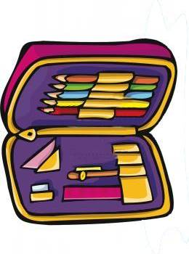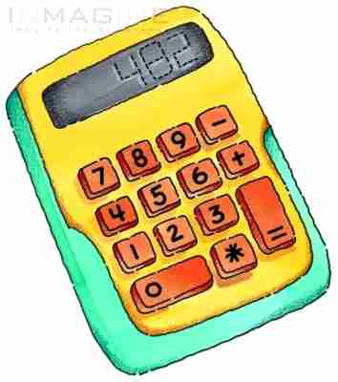
1. There is a yellow notebook under the schoolbag. ______
2. There is a paintbrush under a protractor. ______
3. There is a rubber next to a pen. ______
4. There is a schoolbag behind a ball. ______
5. There is a blue ball. ______
6. There is a calculator behind the ball. ______
7. There aren’t coloured pencils in the pencil case. ______
8. There are two rulers in the schoolbag. ______
9. There isn’t a compass. ______
10. There is a green notebook in the schoolbag. ______
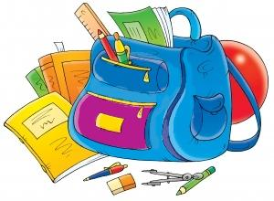

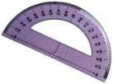

3. Use the image in exercise 2 and complete with prepositions: in- under- behind- between- in front of.
1. There is a protractor _______________ the paintbrush.
2. There are coloured pencils ____________ the pencil case.
3. There is a calculator _________________ the ball.
4. There is a notebook __________________ the school bag.
5. There is a rubber ____________________ the pen and the compass.
6. There are books _____________________ the books.
7. There is a ruler _____________________ the schoolbag.
8. There is a ball ______________________ the schoolbag and the calculator.
9. There is a notebook __________________ the paintbrush.
10. There is a schoolbag __________________ the ball.

4. Look at the picture and write sentences using the correct form of the verb there be and prepositions of place to locate the following objects: pencils- pillow- trainers- chair- cat- study lamp- mat- night table.

5. Look at the picture and answer.
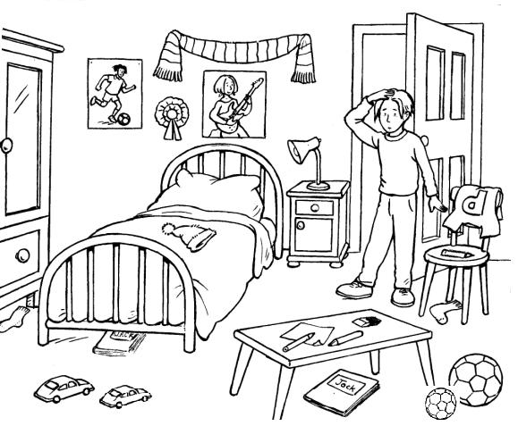

- Is there a book under the bed?
- Are there two balls on the table?
- Where are the balls?
- Is there a pencil on the chair?
- Is there a wardrobe in the room?
- Are there any posters on the wall?
- Are there three pens on the table?
- How many pens are there on the table?
- Where is Jack’s notebook?
- Where are Jack’s socks?

